**Q1 & Q2)** Downloaded and configured Visual Studio 2019.

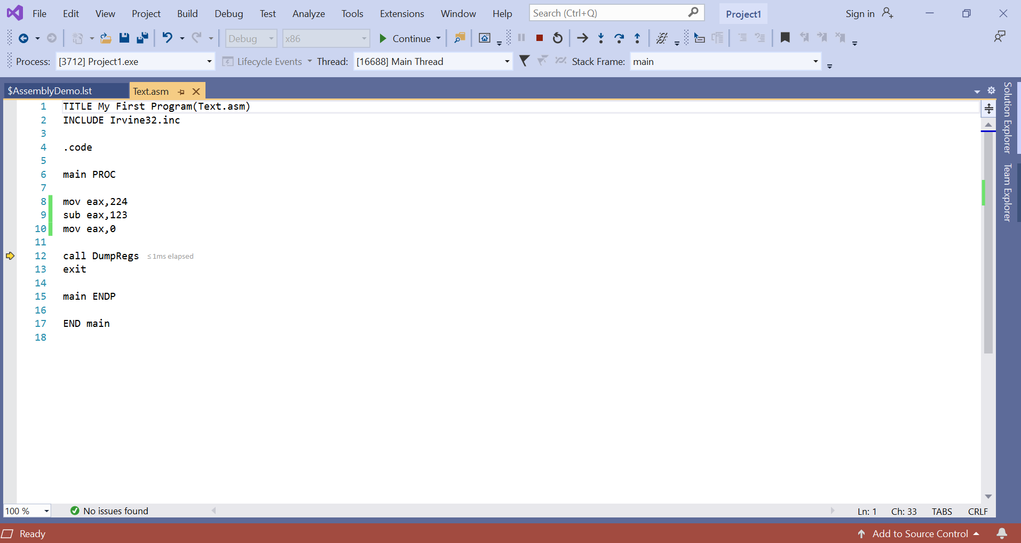

**Q3)**

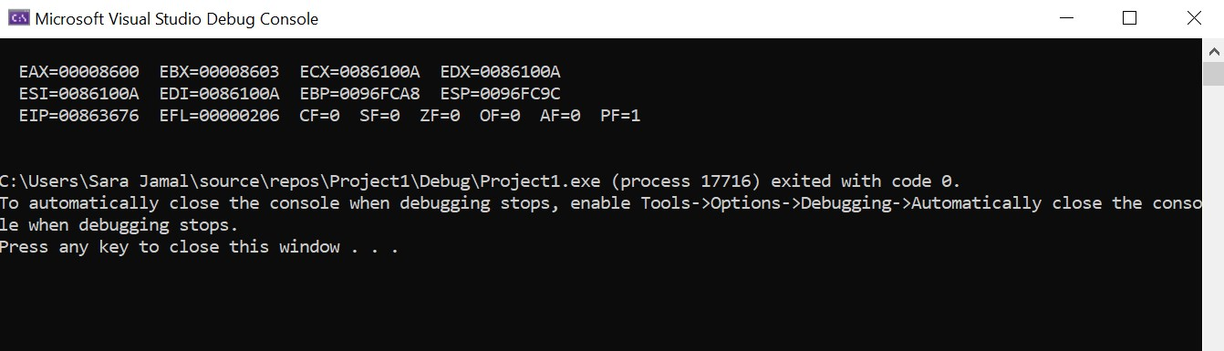

**Q4)**

EAX = 006FFF28 (initial)

EAX = 006FFF28

EAX = 00000008

EAX = 00008600

EAX = 00008600

EAX = 00008600

**Q5)** 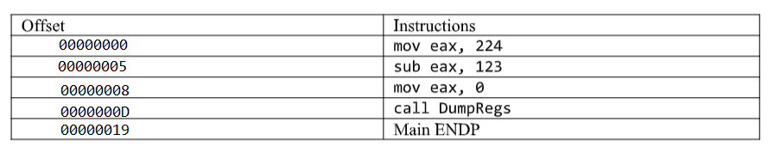

**Q6)** The listing file contains information about the assembly process and how the program is compiled.

**Q7)** Assembler, Editor, Debugger and Linker

**Q8)** An assembler is a program which converts source code in assembly language to object files in machine language.

**Q9)** A linker is a program which combines different object files and link libraries into a single executable program.

**Q10)** A debugger is a program that helps us trace the run-time behavior of a program and detect problems in it.

**Q11)**

